# On-Premises Deployment by setting up Web Server, IIS, SQL Database Server.

Step:1-Install IIS server in the windows System.So go to the Control panel and click on Program and Features. Check for IIS Express if not then download using .

<https://dotnet.microsoft.com/en-us/download/dotnet/6.0> -> select HOTING BUNDLE from left side. Run that .exe.

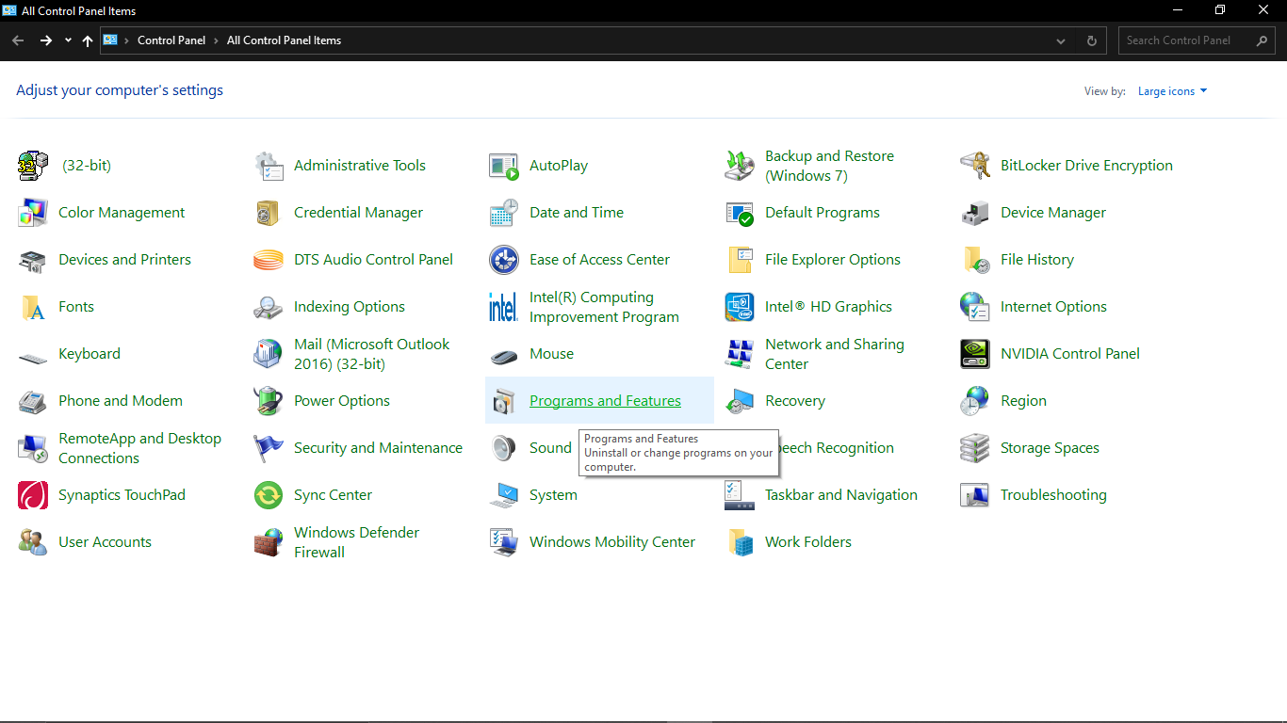

Step 2:- Here we will get the IIS 10.0 Express Installed in our PC. Now one pop up window will open then search for the **Internet Information and enable that one .** 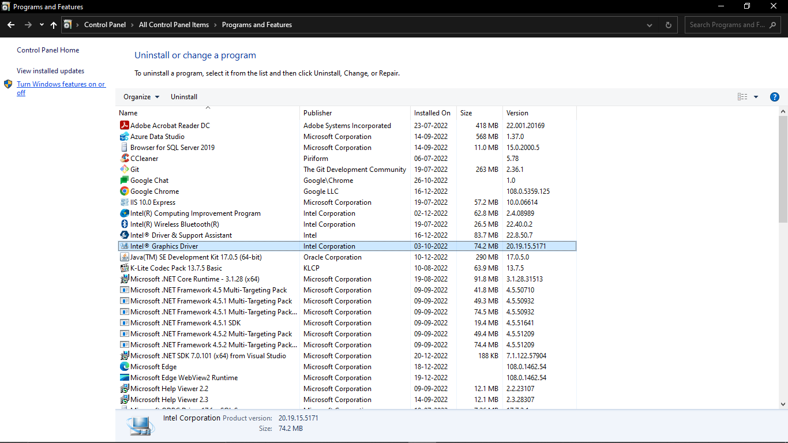

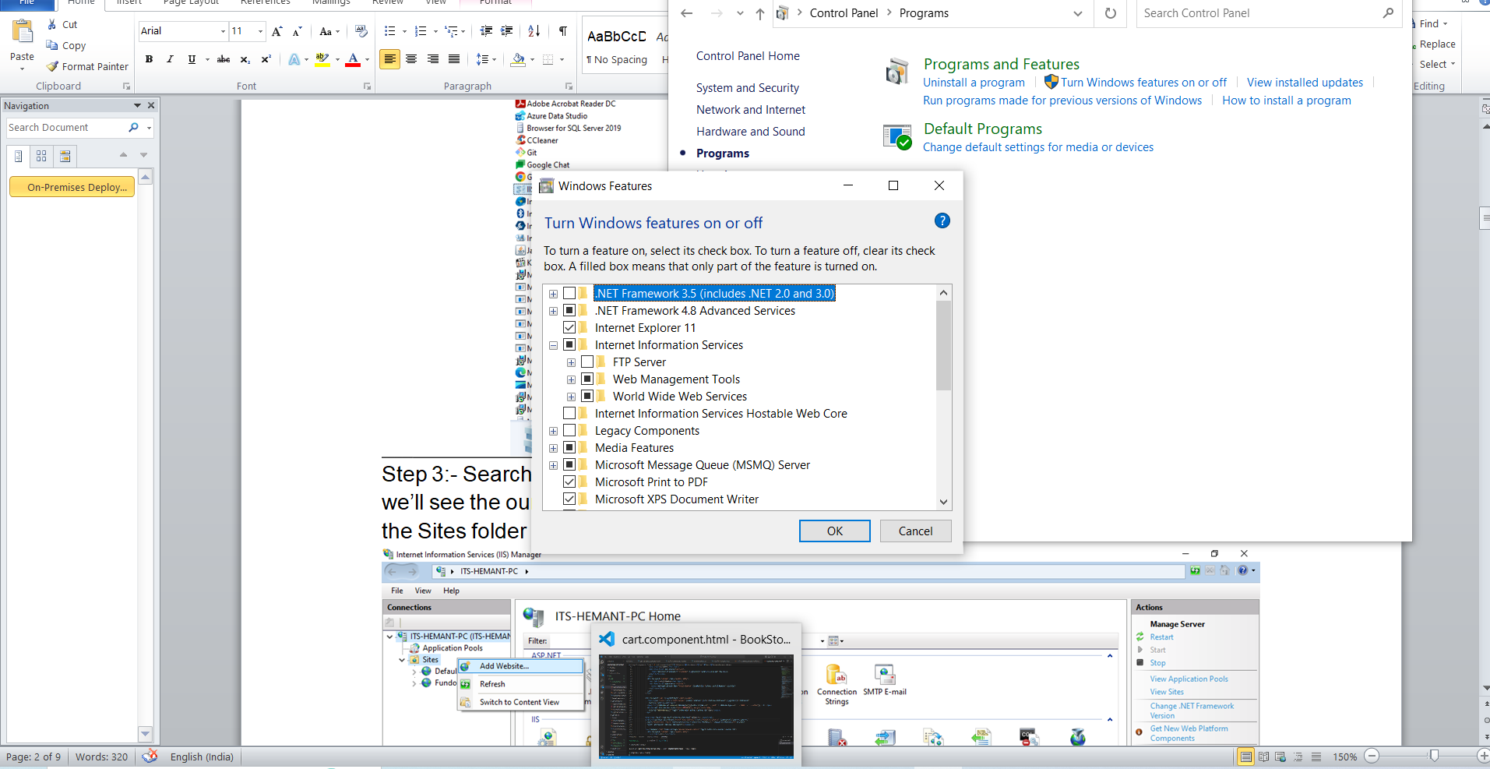

Step 3:- Search for the IIS Manager(Internet Information Manager) in windows search, here we’ll see the our database is connected to the IIS and we have to add site by right clicking the Sites folder

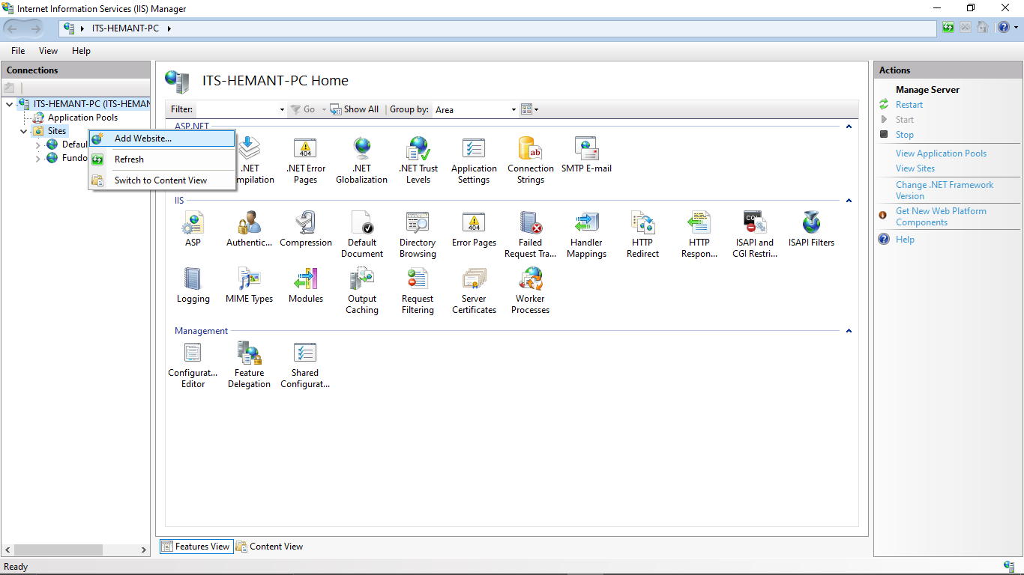

Step 4:- Now Add Website pop up window open. Here we have to do as follows:-

1. **Site Name** :- BookStoreApp
2. Physical Path – C:\inetpub\wwwroot
3. Create folder there and select that path.
4. Give port number . Click **Ok**

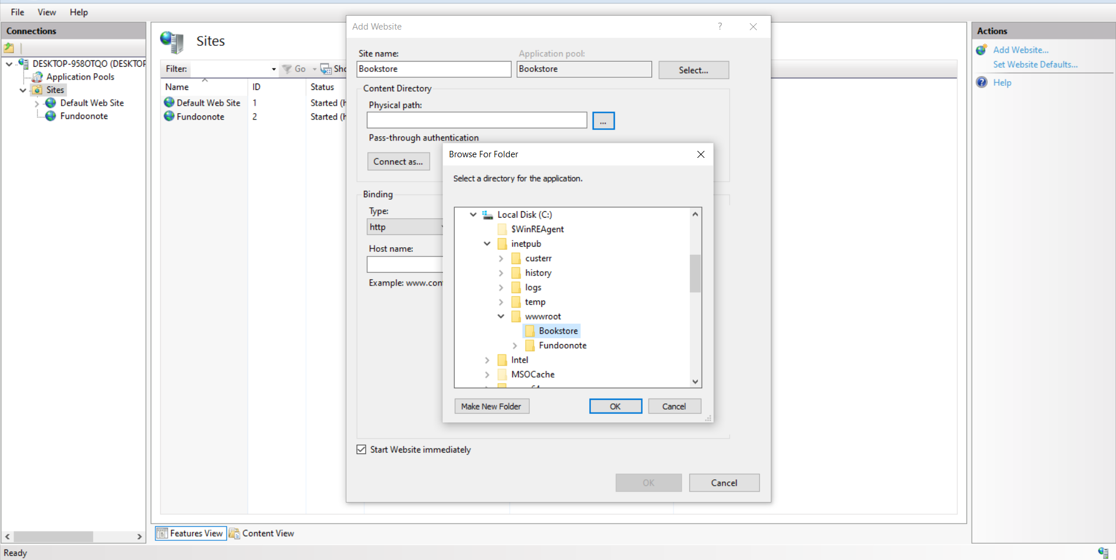

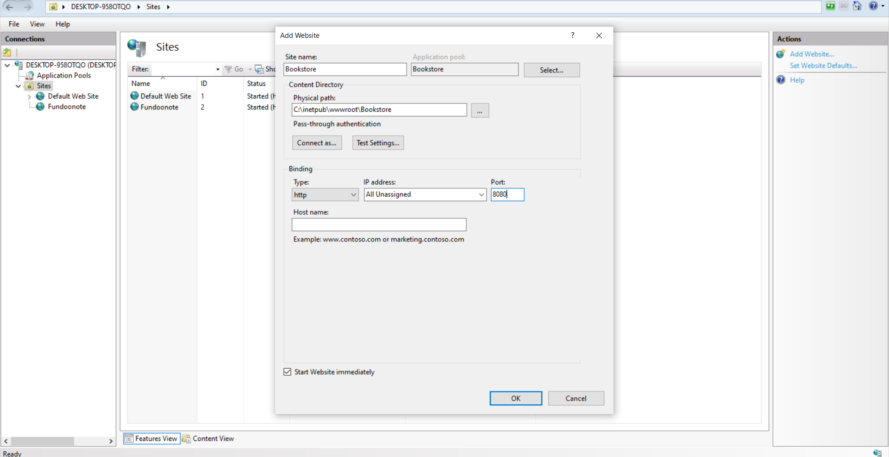

Step 5) Click on Bookstore site and select Manage Website then click on Browse . It will show error or localhost page .Both are fine.

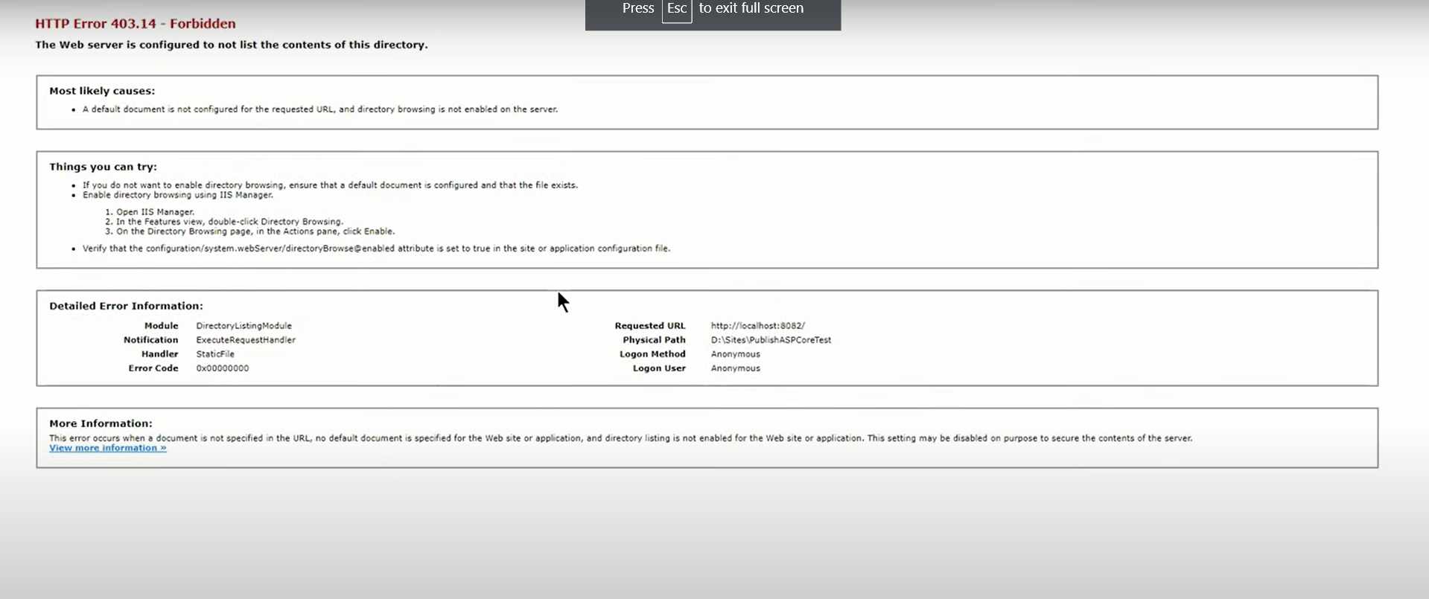

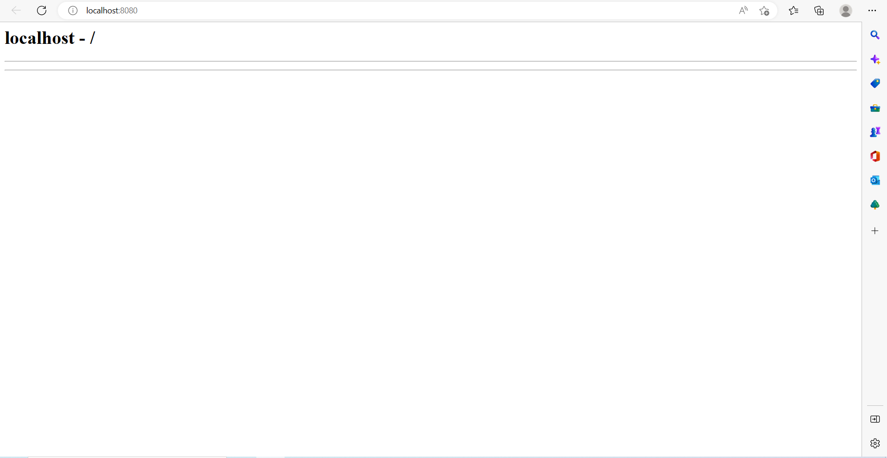**Publish application**

Step 6) Go to visual studio -> click on project -> click on Publish 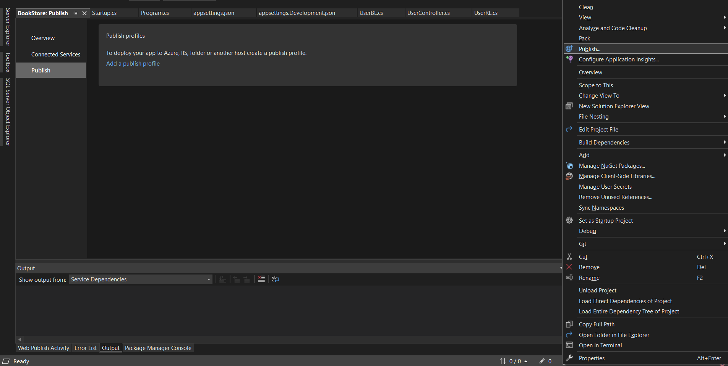

Step 7) Pop Up window will came -> Select Web Server(IIS) -> Select Web Deploy -> click on Next button.

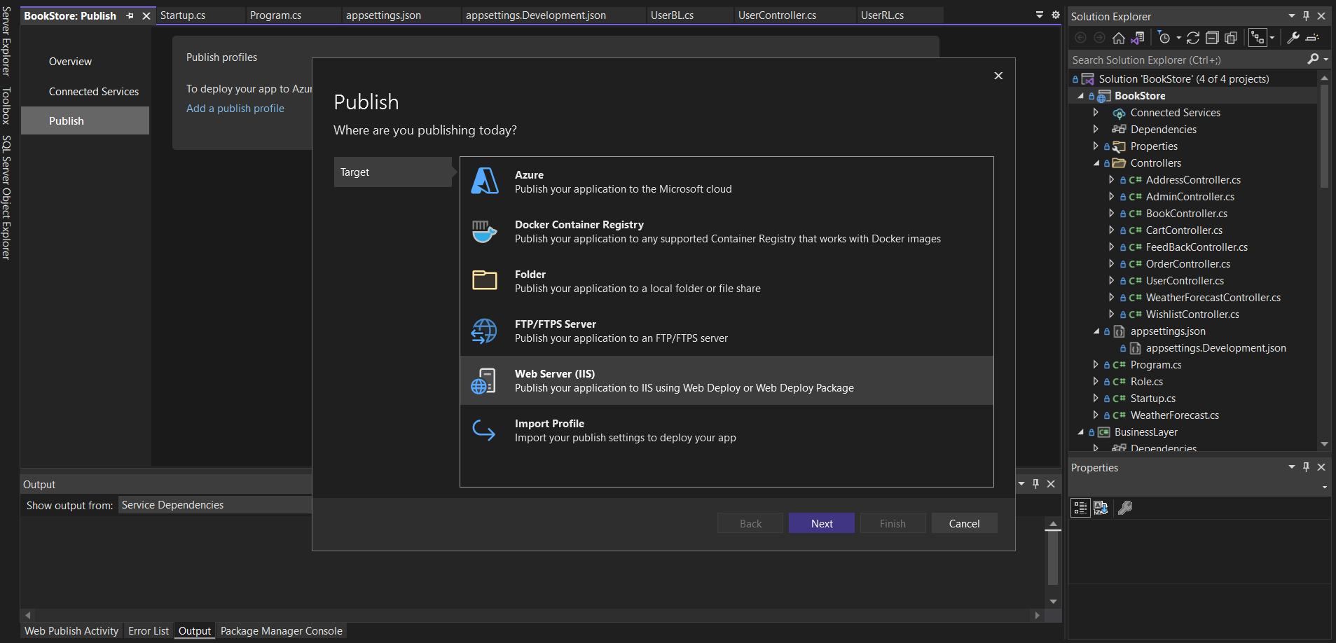

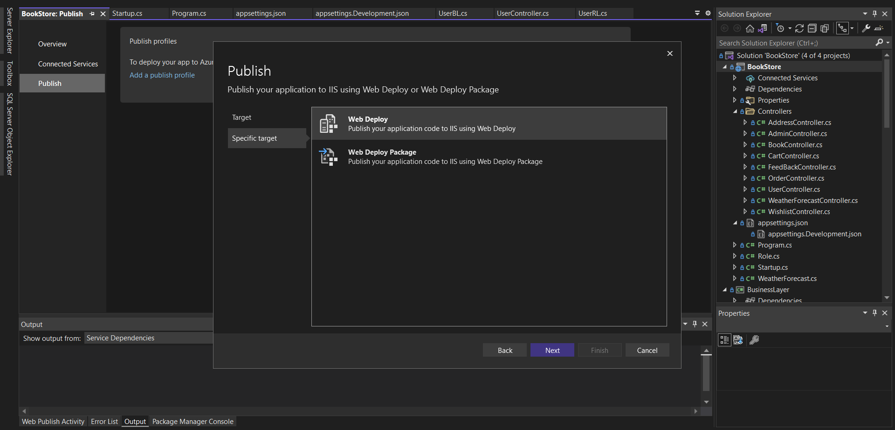

Step 8) 1)**Server** - name is localhost because IIS is located in localhost.

2)**Site Name** – same as in IIS Bookstore

3)**Destination URL** – go to IIS select site -> manage website -> Browse ->

Copy path of url and pest here [localhost - /](http://localhost:8080/)

4)Click on Finish. Now our project is ready to publish.

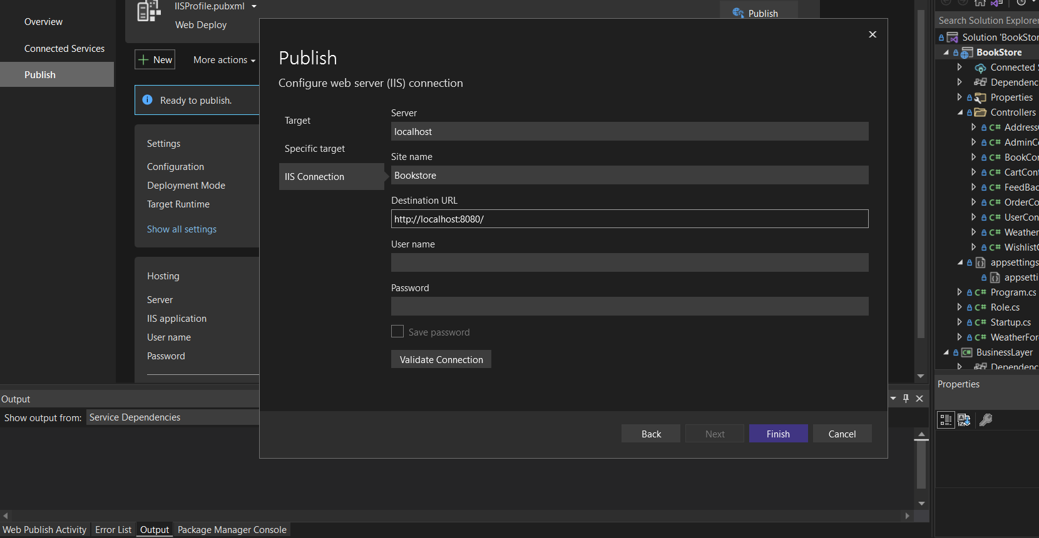

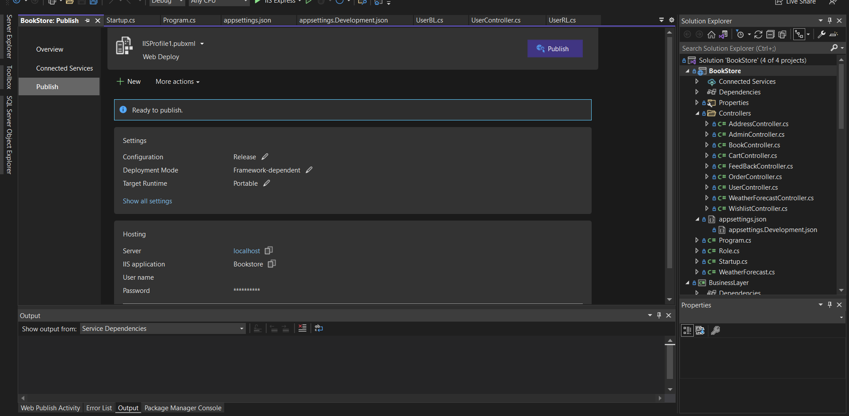

Step 9) Close VS and Open as a Administrator. Goto tp project-> Publish ->Already everything is done for publish, Now click on Publish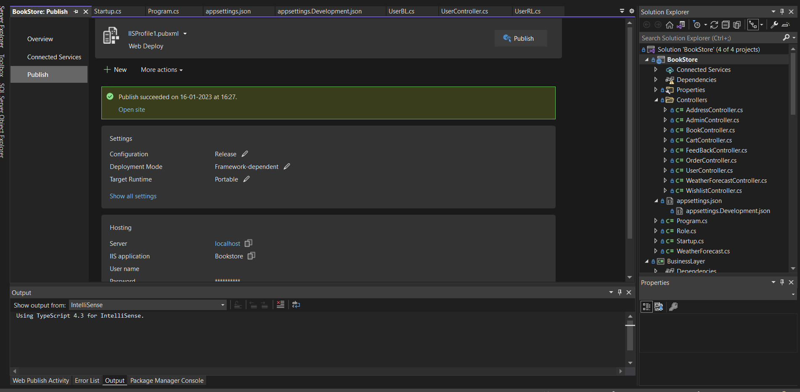

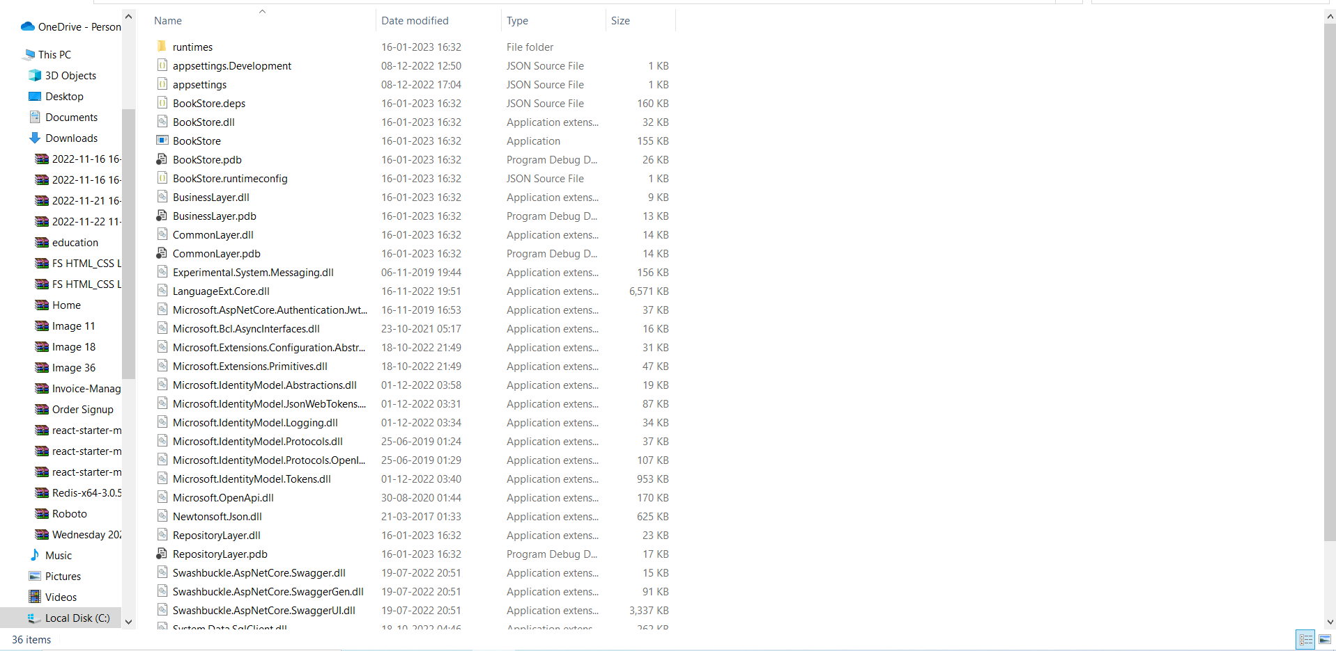

Step 9) Give path for after port

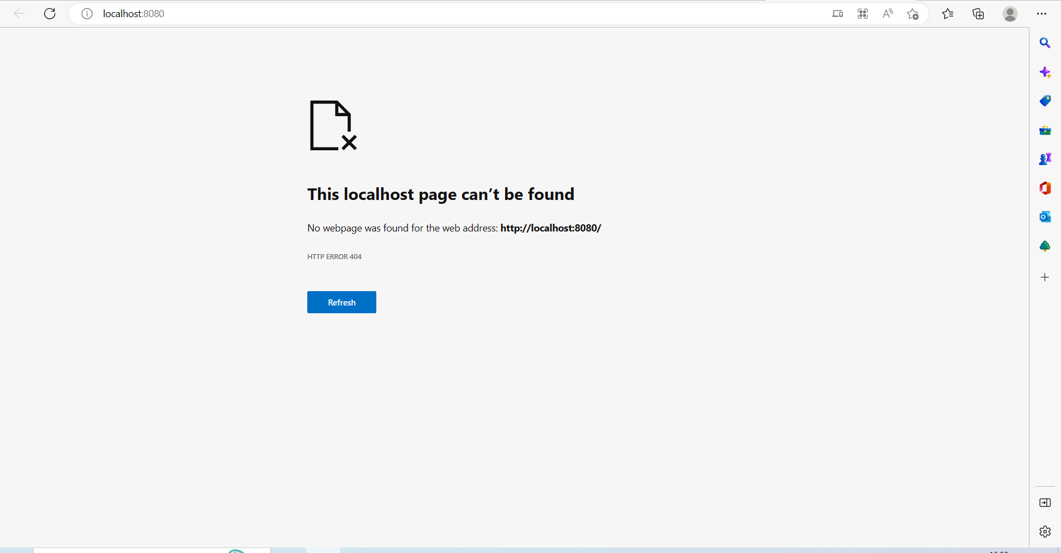

Step 9) Give path for after port

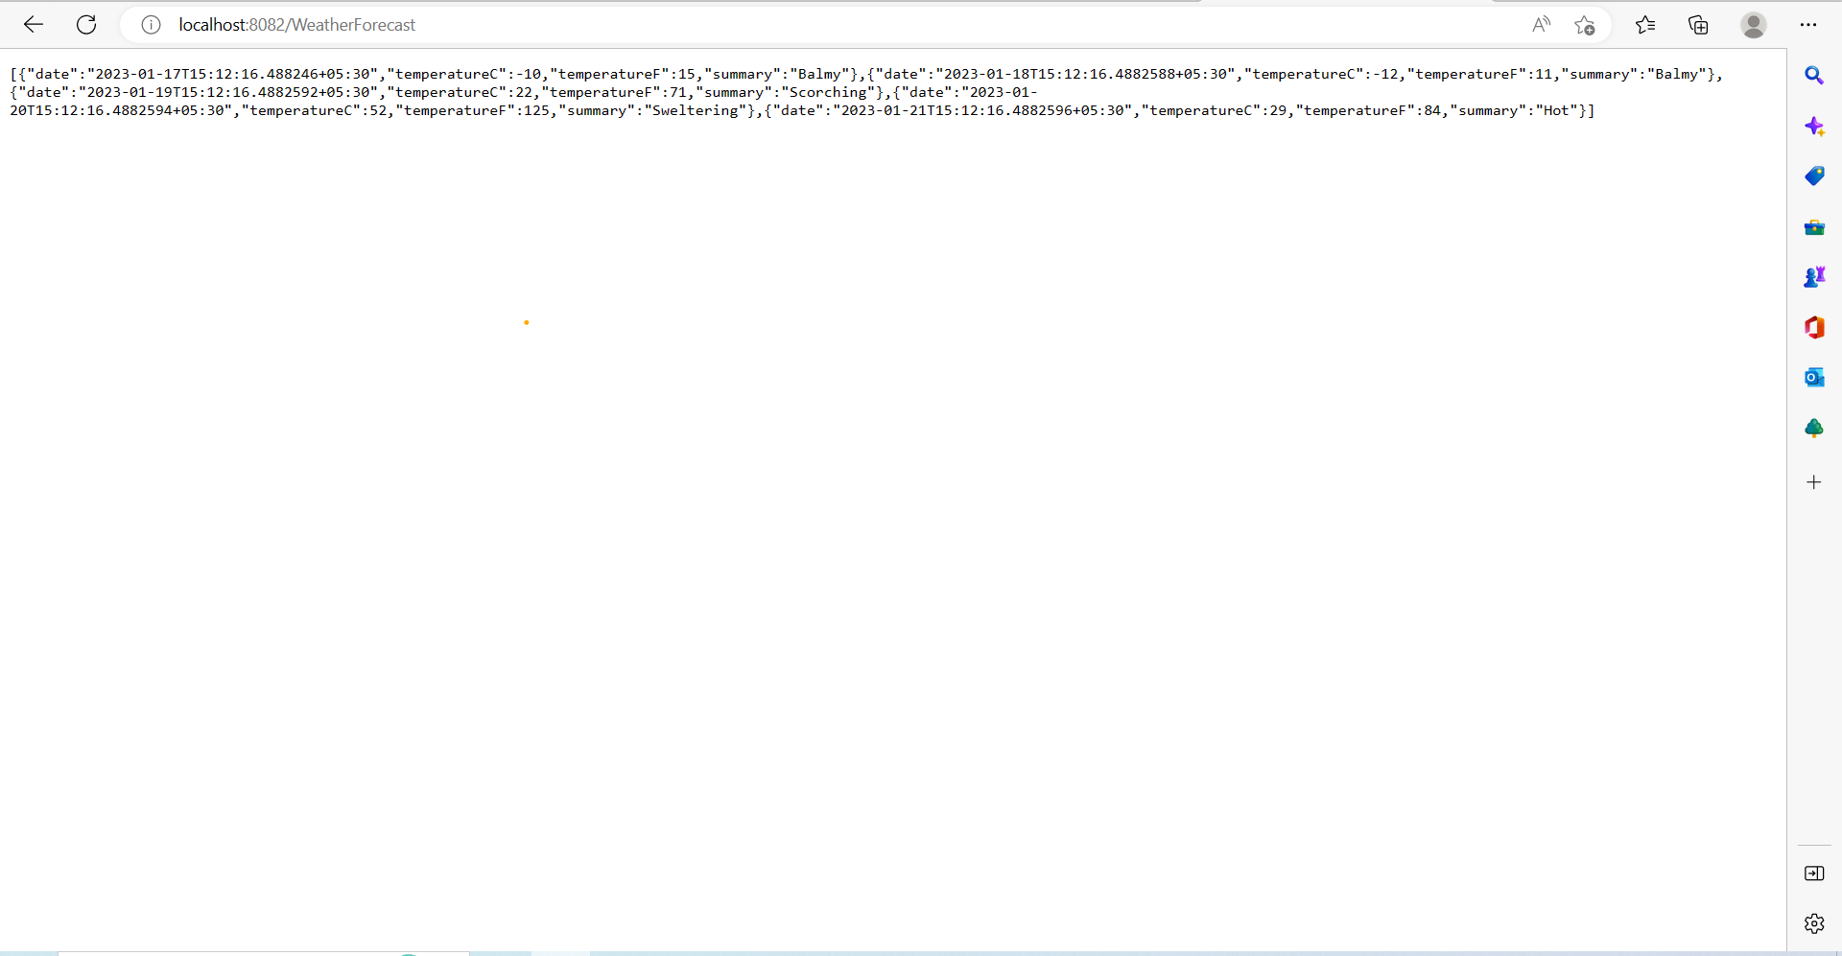

Step 11) Change in lauchsetting.json for default swagger path.

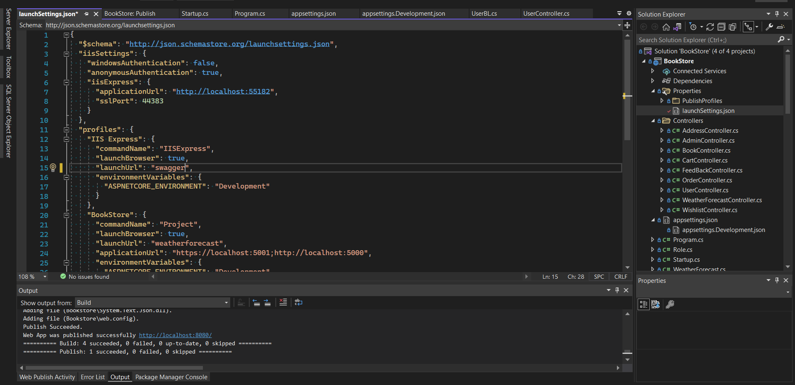

Now check again

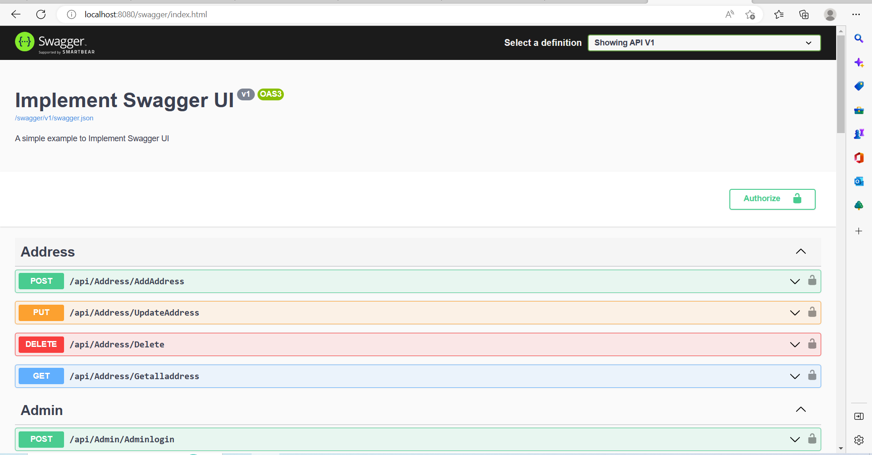

For reference - https://www.youtube.com/watch?v=PdsgiiLzQ18